HIMANSHU 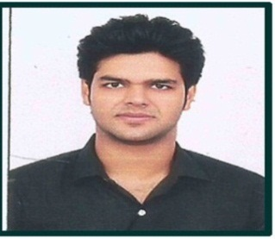

Vill:Bhamrouli , Post:Palipartapur
Pincode:245405 ,Dist:Bulandshahr (U.P)

Mobile- +91-9639670967

E-mail- himanshu.sirohi11@gmail.com

OBJECTIVE:

Dedicated, dynamic Electrical Engineer with a Bachelor degree, seeking an result oriented opportunity to work in the established and prestigious organisation.

ACADEMIC QUALIFICATION(S):

EXAMINATION | BOARD/UNIVERSITY | YEAR | AGGREGATE %
B.Tech (EEE) | UPTU- Lucknow | 2015 | 68.6
Intermediate | CBSE | 2011 | 69.20
High School | CBSE | 2009 | 72.20

EXPERIENCE:-

- Organization:- Su-Kam Power Systems Ltd.
Duration:- From June,2015 to October, 2016.
Location:- Sector-37, Gurgaon, Haryana.

- Organization:- DRS Energy Pvt. Ltd.
Duration:- From October, 2016 to October, 2017.
Location:- Sector 63, Noida, U.P.

- Organization:- Plaza Power & Infrastructure Company.
Duration:- From Nov, 2017 to till date.
Location:- Okhla Phase II, New Delhi.

JOB DESCRIPTION & RESPOSIBILTIES:-

- Arrange the existing material as per available stock of factory.
- Take quotation from vendors (Wires & Solar Panel).
- Arrange the sample for product development for quality check.
- Issue Purchase order as per our requirement.
- Maintain records of goods ordered and received.
- Follow-up with vendors regarding the delivery of material.
- Co-ordinate with freight forwarder for the import of material.
- Update all purchase order in FCA.
- Developed the vendor for OEM of Battery.
10. Arrange the material the Solar Power Generating System such as solar panel, inverter, AJB, ACDB, & LA etc.
11. Follow-up with account department regarding the payment of vendors as per there payment terms.

TECHNICAL SKILLS:

- Good Knowledge of FCA.

- KNOWING OFFICE PACKAGE- MS WORD, MS EXCEL, MS POWERPOINT.

- KNOWING OPERATING SYSTEMS- WINDOWS 2000, XP, WINDOWS 8.

PERSONAL DETAILS:

NAME | : | - Himanshu
FATHER’S NAME | : | - MR. Rajkumar Sirohi
D.O.B | : | - 26/02/1994
NATIONALITY | : | - Indian
HOBBIES | : | - Travelling ,listening music ,playing cricket

DECLARATION:

I do hereby declare that the personal and professional information, mentioned above are

true to best of my knowledge and belief.

PLACE: HIMANSHU

